Human security assistance system with GPS location tracking and messaging system

A PROJECT REPORT

<Font Size 14><Font Style Times New Roman – Bold>

Submitted by

Ashkaran Bisnoe

NAME OF THE CANDIDATE(S)

Anushka Singh,
Mukta Tehri,
Aaditya Amitabh,
Kaphi Rani,

in partial fulfillment for the award of the degree of

<Font Size 14><1.5 line spacing><Italic><Font Style Times New Roman – Bold>

NAME OF THE DEGREE

<Font Size 16><Font Style Times New Roman – Bold>

IN

BRANCH OF STUDY

<Font Size 14><Font Style Times New Roman>


Chandigarh University

MONTH & YEAR

<Font Size 14>

TITLE OF PROJECT REPORT

A PROJECT REPORT

Submittedby

Anushka Singh, (21CBS1001)

Mukta Tehri,(21CBS1003)

Aaditya Amitabh, (21CBS1033)

Kaphi Rani,(21CBS1059)

in partial fulfillment for the award of the degree of

BACHELOR OF ENGINEERING

IN

ELECTRONICSENGINEERING


Chandigarh University

MAY 2023

BONAFIDE CERTIFICATE

<Font Style Times New Roman – size -16>

<Font Style Times New Roman – size -14>
Certified that this project report “TITLE OF THE PROJECTHuman security assistance system with GPS location tracking and messaging system” is the bonafide work of “Anushka Singh, (21CBS1001), Mukta Tehri,(21CBS1003), Aaditya Amitabh, (21CBS1033), Kaphi Rani,(21CBS1059)” who carried out the project work under my/our supervision.

<<Signature of the HoD>>

SIGNATURE

<<Name of the Head of the Department>>

HEAD OF THE DEPARTMENT

<<Department>>

<<Signature of the Supervisor>>

SIGNATURE

<<Name>>

SUPERVISOR

<<Academic Designation>>

<<Department>>

Submitted for the project viva-voce examination held on

INTERNAL EXAMINER EXTERNAL EXAMINER

TABLE OF CONTENTS
List of Figures i
List of Tables ii
Abstract iii
Graphical Abstract iv
Abbreviations v
Symbols vi
Chapter 1 4

1.1 ................................................................................................................................ 5

1.2 ..................................................................................................................................

1.2.1 ..........................................................................................................................

1.3 ..................................................................................................................................

1.3.1 ..........................................................................................................................

1.3.2 ..........................................................................................................................

Chapter 2. ....................................................................................................................

2.1 ..................................................................................................................................

..................................................................................................................................

2.2 ..................................................................................................................................

..................................................................................................................................

Chapter 3. ....................................................................................................................

Chapter 4. ………………………….………………………………………...

Chapter 5. ……………………………………………………………………

References (If Any) ......................................................................................................

List of Figures

Figure 3.1 ………………………………………………………………………………….

Figure 3.2 ………………………………………………………………………………….

Figure 4.1 …………………………………………………………………………….…

List of Tables

Table 3.1 ………………………………………………………………………………….

Table 3.2 ………………………………………………………………………………….

Table 4.1 …………………………………………………………………………….……

ABBREVIATIONS

- GPS: Global Positioning System
- IMU: Inertial Measurement Unit
- INS: Inertial Navigation System
- INFOSEC: Information Security
- IoT: Internet of Things
- IIoT: Industrial Internet of Things
- IP: Internet Protocol
- IR: Infrared
- IS: Information Security / Islamic State
- ISO: International Organization Standardization
- ISS: International Space Station
- FEWS NET: Famine Early Warning System Network
- GIS: Geographic Information System
- GPM: Global Precipitation Measurement mission
- A2 / AD: Anti-access / Area Denial
- DOS: Denial of Service cyber attack
- DPRK: Democratic People’s Republic of Korea
- FAA: Federal Aviation Administration
- DSA: Detect, sense and avoid / Dynamic Sense-and-Act
- DSS: Decision Support System
- DSSS: Direct sequence spread spectrum
- GLOW: Gross lift-off weight for a missile / rocket
- GNSS: Global Navigation Satellite System
- GLONASS: Global Satellite Navigational System
- GPSSPOOF: Hack of GPS system affecting UAS commands
- GPWS: Ground proximity warning system
- SPS: Standard position service (GPS)
- SSA: Static Sense-and-Act

ABSTRACT

The use of the Human Security Assistance System with GPS Location Tracking and Messaging System can enhance several aspects of human security. Along with helping to avoid crime and terrorism, the suggested methodology can also be used in client management. Practitioners can learn more about GPS technology and how it might impact an agency's supervision program by using this system. It is possible to use the system to alert those around and ensure women's safety in an emergency. With the ability to track users' whereabouts and send emergency contacts SMS notifications, the system is a helpful instrument for ensuring human security. The software and the Nodemcu ESP8266 microcontroller of the device. Software for the Arduino IDE is used in the system in conjunction with the Nodemcu ESP8266 microcontroller. Furthermore, a resistive sensor that is a component of the system is managed by an Internet of Things-based wearable human protection system. The proposed model can ensure the protection of individuals, especially women, children, and the old. The technology can be used to determine specific container locations, contents, and whether or not they have been opened. Large-scale population movements are tracked using the Global Positioning System (GPS) technology during humanitarian disasters. The technology can be used to find the user in addition to notifying hospitals and fire stations in the case of an accident or fire. The proposed model may be a helpful tool for ensuring the security of people as well as individual safety.

GRAPHICAL ABSTRACT

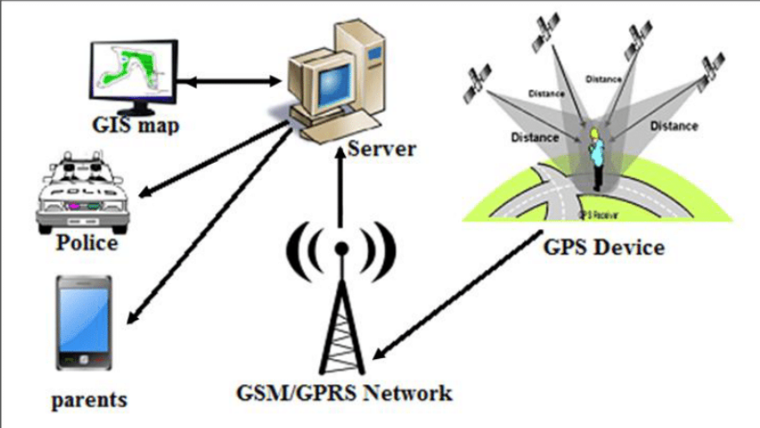

CHAPTER 1: INTRODUCTION
1.1 Introduction:
An approach for human security monitoring that can be utilized to guarantee people's protection is the Human Security Assistance System with GPS Location Tracking and Messaging System. With its people-centered and multidisciplinary approach to security, the paradigm of human security challenges the conventional idea of national security in order to grasp global vulnerabilities.
Various aspects of human security can be improved and client management can be implemented with the help of the suggested model. Through the use of the system, practitioners can have a deeper comprehension of GPS technology and how it may affect the supervisory program of an organization. When an emergency arises, the system can be utilized to notify those in the vicinity and protect the safety of women.

It is an efficient instrument for maintaining human security because the system may be used to
track people's whereabouts and can notify emergency contacts via SMS. Individual safety, particularly that of women, children, and the elderly, can be guaranteed by utilizing the suggested approach. In addition to sending notifications to fire stations and hospitals in the event of an accident or fire warning, the system can be used to determine where the user is. Individual safety and human security can both be effectively ensured with the help of the suggested model.

1.2 Problem Identification
Current considerations that are pertinent to a human security system are as follows:
• Privacy: The use of GPS technology to track people creates concerns over the right to privacy. The amount of information that may be gleaned from a person's movements and the potential applications of that knowledge are sources of concern. Laws pertaining to geolocation privacy forbid the use of this technology for regular surveillance purposes.

• Ethical concerns: There are significant ethical questions raised by the capability to track an individual's travels via GPS. Even when permission is originally granted, ongoing surveillance of a subject's activities by a researcher carries the risk of invasion of privacy and psychological fallout from the sensation of being "watched."

• Technological developments: Preventing crime and terrorism in the twenty-first century will depend more and more on technology. It is possible to stop crime and terrorism by using GPS technology. But technological progress might sometimes result in privacy violations.

• Humanitarian emergencies: In times of humanitarian crisis, GPS technology is utilized to track large-scale population migrations. In order to monitor large-scale population movements during humanitarian crises, United Nations agencies, particularly UNHCR, use space technologies like satellite imagery, Geographic Information Systems (GIS), and the Global Navigation Satellite System (GNSS).
• New location-based technologies: In an attempt to learn more about the current status of the GPS industry and possible future trends, a survey was sent to GPS community monitoring businesses. The research examines the current status of GPS devices for community monitoring as well as the development of new location-based technologies.

These modern concerns can be taken into account while developing a human security system project that uses GPS location to protect people while resolving ethical and privacy considerations.

1.3 Task Identification:
The following activities must be recognized and completed in order to create a human security system that uses GPS location:

Determine the essential elements of human security: The project team must ascertain the essential elements of human security, which encompass safeguarding against long-term dangers including malnourishment, illness, and persecution, as well as defense against abrupt and harmful disturbances to everyday routines. This will make it easier to make sure that the system is built to handle the most serious risks to the security of people.

The project team must create a location-based personal task reminder for mobile users in order to guarantee that the system is efficient and easy to use. This will guarantee that people are able to recall crucial assignments and appointments.
The project team must examine GPS data for psychological research in order to gain a deeper understanding of how people utilize GPS technology and how it affects their sense of security. This will make it easier to guarantee that the system is made to accommodate different needs and effectively improve human security.

Determine possible risks to human security: The project team must determine possible risks to human security, such as armed conflicts, health problems, law and order problems, state power, the economy, and the environment. This will make it easier to make sure that the system is built to handle the most serious risks to the security of people.

The project team must create a system that is both flexible and adaptive so that it may be updated and changed in response to the emergence of new technologies. That way, the system's ability to improve human security over time will be strengthened.

The project team can create a user-friendly, efficient, and flexible human security system that can be adjusted to new needs and technological advancements by recognizing and tackling these objectives. The system will utilize GPS location.

1.4 Timeline
The fictitious chronology listed below can be taken into consideration while creating a human security system that uses GPS location:

Phase 1: Identify the essential elements of security for people and any risks to those elements.
- Provide a mobile user-friendly personal task reminder that is location-based.
* To learn more about how people utilize GPS technology and how it affects their sense of security, do psychological research using GPS data analysis.

Phase 2: Provide an adaptive and flexible system that can be updated and changed in response to the emergence of new technologies.
- To test the system and get user feedback, do a pilot study.
- Discuss privacy issues and moral issues surrounding the usage of GPS technology.

In phase three, the system is refined in response to input from the pilot research.
- Carry out a more extensive investigation to see whether the system is beneficial in improving human security.
- Create a plan to expand the system's reach to a larger audience.

Phase Four: Establish the system in an actual environment.
- Track system performance and make required modifications in response to user input.
- Keep discussing ethical issues and privacy concerns pertaining to GPS technology use.

Phase 5: Assess how the system will affect human security in the long run.
Formulate a strategy for long-term system maintenance.
- Promote the use of GPS technology to improve human security by disseminating research findings and best practices to other organizations and stakeholders.

The project team can create a user-friendly, efficient, and flexible human security system that can be adjusted to new needs and technological advancements by adhering to this fictitious timeframe.

CHAPTER 2: LITERATURE SURVEY
2.1 Existing Work
Timeline of the Reported Issue as Examined Globally: 2003 saw the release of "Human Security Now," a report by the Commission on Human Security that emphasized the need to protect and uphold people's fundamental liberties and advocated for a new strategy for development that would enable people to live without hunger, fear, anxiety, or humiliation.

2012: The Secretary-General reports to the General Assembly on the progress made in the field of human security since the World Summit in 2005. The paper highlights major human security projects carried out by countries, intergovernmental organizations at the regional and sub-regional levels, and UN agencies and authorities.

2019: A paper is released discussing the moral issues surrounding the use of GPS-based mobility tracking in medical studies. The study emphasizes the significance of discussing ethical
risks associated with privacy and data security breaches.

2022: The "2022 Special Report on Human Security," released by the United Nations Development Programme, looks at a number of risks that have changed and become more noticeable recently, including those posed by digital technology. The study reveals that after years of successful upward progress, people's perception of safety and security is at an all-time low in practically every nation, even the wealthiest nations.

General Assembly convenes in 2023 to discuss the Secretary-General's report, "Follow-up to General Assembly Resolution 64/291 on Human Security." The final section of the study includes a series of suggestions meant to encourage the integration of human security into UN operations and the use of it as an overarching framework in the post-2015 Development Agenda.

2023: Space and Water: Towards Sustainable Development and Human Security, an international conference, has a keynote speech. The use of GPS technology to find specific container locations, contents, and whether or not they have been opened is discussed in the lecture. In addition, the presentation emphasizes how satellite imagery, Geographic Information Systems (GIS), and the Global Navigation Satellite System (GNSS) are used to track large-scale population migrations in times of humanitarian crisis.

The need to address concerns about GPS use and human security is becoming more pressing, as evidenced by an international investigation into the subject. The results of these reports and investigations can help with the creation of a human security system that uses GPS location is efficient, easy to use, and takes privacy, ethics, and technology issues into account.

2.2 Problem:
The usage of GPS technology raises privacy concerns.
- The usage of GPS technology and its ethical implications.
- Potential privacy breaches brought on by technological improvements.
Difficulties in guaranteeing that GPS technology be applied with efficacy and efficiency in humanitarian crises.
- New technologies that are location-based.

2.3 Goals:
- Building an adaptive and flexible system that can be updated and changed in response to the emergence of new technologies.
- Addressing ethical and privacy issues around the use of GPS technology.
Determining possible dangers to the safety of people.

2.4 Objectives:
- - Creating a tailored task reminder for mobile users based on location.
- To learn more about how people utilize GPS technology and how it affects their sense of security, psychological researchers are analyzing GPS data.
- To test the technology and get user input, a pilot study will be carried out.
- - Making system improvements in response to input from the pilot study.
- - Carrying out a more extensive analysis to determine how well the system improves human security.
- - Creating a strategy for expanding the system's reach to include more users.
- - Watching the system and modifying it as needed in response to user input.
- Assessing how the system will affect human security in the long run.
- Formulating a strategy to maintain the system in the long run.
- Encouraging the use of GPS technology to improve human security by disseminating research results and best practices to other organizations and stakeholders.

promoting the application of GPS technology to enhance human security by sharing best practices and research findings with other organizations and stakeholders.

CHAPTER 5: CONCLUSION AND FUTURE SCOPE
5.1 Conclusion:
Recently, there has been a lot of interest in the application of GPS technology to human security systems. A location-based personal task reminder for mobile users, GPS data analysis for psychological research, and population monitoring during humanitarian crises are just a few of the potential uses of GPS technology for improving human security that are highlighted in the literature review. Even said, a number of difficulties and problems are also brought to light by the search results, including emerging location-based technologies, ethical dilemmas, privacy issues, and technology developments. To overcome these obstacles and create a system that is adaptive and flexible enough to be updated and changed as new technologies are developed, these are the project's intended goals and objectives. Through the creation of a GPS-based human security system, Individual safety can be guaranteed while resolving ethical, technological, and privacy concerns. The search results reveal important information on the possible uses of GPS technology in human security systems and emphasize the necessity for more study in this field.

5.2 Future Scope:
The search results reveal important information on the possible uses of GPS technology in human security systems and emphasize the necessity for more study in this field. Future research could focus on a few of these areas:

constructing a thorough framework using GPS position for a human security system: In order to guarantee that the system is efficient, user-friendly, and takes privacy, ethics, and technology issues into consideration, a thorough framework for human security systems utilizing GPS location should be developed.

Further research should be done on the possible uses of GPS technology in analyzing human movement patterns. Several publications have emphasized the use of GPS technology in this regard. New avenues for improving human security may be found with the aid of more research in this field.
Discussing privacy issues and moral issues around the usage of GPS technology: The necessity to resolve privacy issues and moral dilemmas surrounding the usage of GPS technology is made clear by the search results. Subsequent efforts should concentrate on formulating approaches to tackle these issues and guarantee that the framework is crafted to safeguard the rights of individuals to privacy.

Creating a strategy for expanding the system's reach to a larger market: The findings of the search demonstrate how GPS technology can be used to protect people, particularly women, children, and the elderly. In order to reach a larger audience and guarantee that it is available to those who need it most, future work can concentrate on creating a plan for scaling up the system.

Assessing how the system will affect human security in the long run: The search results emphasize how important it is to assess how the system will affect human security in the long run. Prospective research endeavors may concentrate on formulating approaches to assess the system's efficacy in the long run and pinpoint avenues for enhancement.

Chapter 3: Design flow/Process
3.1 Concept Generation:
Improving personal safety and offering support when needed can be accomplished with the help of a Human Security Assistance System with GPS location tracking and messaging system. Several advantages of implementing such a system include the following:

1. Increased Personal Safety: Because of the system's ability to immediately track and report a victim's whereabouts to authorities, potential offenders may be less inclined to target individuals in crimes or harassment.

2. Real-Time Location Tracking: In an emergency, the system may give emergency personnel real-time location data, facilitating their prompt and efficient arrival to the scene.

1. Two-Way Communication: The messaging function enables two-way communication between the user and pre-designated contacts, allowing the latter to offer support and help in times of need.

2. Individual and Family Peace of Mind: Having a backup plan to assist them in an emergency can give people and families a sense of security.

3. Empowerment for Vulnerable People: By enabling them to seek assistance and defend themselves, the system can empower vulnerable people, including women, children, and the elderly.

4. Data-Driven Insights for Safety Improvement: To help with preventative measures and safety interventions, the system can produce useful data on safety patterns and potential dangers.

5. Integration with Current Emergency Services: The system can be connected to current emergency services, improving their capacity to respond to crises and help people in need.

6. Potential for Wider Applications: The underlying technology can be modified for a number of uses other than personal security, such as keeping tabs on the locations of people with special needs or tracking assets in a business environment.

3.2 Evaluation & Selection of Specifications/Features:
In order to guarantee that a Human Security Assistance System with GPS Location Tracking and Messaging System (HSAS) is effective in protecting people and delivering aid in an emergency, it is imperative that the right specifications and features be evaluated and chosen. This detailed guide will assist you in assessing and choosing the essential elements of an HSAS:
Accuracy of GPS Position Monitoring:
1. To enable precise tracking of the user's whereabouts, the GPS module should deliver high-precision location data.

2. Coverage: The system ought to continue providing dependable GPS coverage in a range of conditions, such as indoor, outdoor, and rural ones.

Real-time Updates: To make sure that the user's location is always known, the system should offer location updates in real-time or very close to it.

The GPS module ought to possess energy efficiency in order to reduce battery consumption and prolong the device's functioning duration.

Messaging System

1. Two-way communication: Sending and receiving messages in both directions should be possible with the system between the user and assigned contacts.

2. Message transmission: Message transmission should be dependable, especially in places where cellular coverage is spotty.

3. Emergency Alerts: A means for alerting selected contacts to an emergency should be built into the system, making it obvious that immediate assistance is required.

4. communication Encryption: In order to preserve user privacy and communication confidentiality, the system needs to incorporate encryption mechanisms..

Additional Specifications

1. gadget Form Factor: To facilitate inconspicuous use and simple carrying, the gadget should be small, light, and portable.

2. Battery Life: In order to guarantee continued use without frequent charging, the gadget needs a lengthy battery life.

3.Durability: The equipment needs to be strong enough to resist normal wear and tear and continue to work in a range of weather circumstances.

4. Usability: The gadget should be easy to use, especially in high-stress circumstances, with a straightforward interface that makes activation and operation simple.
5. Cost-Effectiveness: To be usable by a larger group of people, the system must be affordable.

Selection Process
1. Clearly identify the goals and requirements of the target consumers while taking into account their preferences, usage habits, and safety concerns.

2. Assess Available Solutions: Examine and compare the features, technical details, and operational capabilities of the many HSAS solutions on the market to the demands that have been stated by the user.

3. Evaluate the HSAS's compatibility with the current emergency services and security infrastructure while thinking about integration to guarantee smooth data flow and integration.

4. Perform User Testing: Find out how the selected HSAS is accepted, useful, and effective by holding user testing and feedback sessions.

5. Constant Evaluation: Analyze and assess the HSAS's performance on a regular basis, pinpointing areas that require improvement and adjusting as technology and user needs change.

3.3 Design Constraints– Regulations
Ensuring compliance, privacy protection, and user safety in the design and implementation of a Human Security Assistance System (HSAS) with GPS location tracking and messaging system necessitates careful consideration of numerous regulatory and design restrictions. Here are a few crucial points to remember:
3.4 Data Security and Privacy
Comply with applicable data privacy laws, such as the CCPA and GDPR, with regard to the gathering, storing, and utilization of personal data, including location data and user messages.

2. Consent and Transparency: Before collecting users' personal information, get their express informed consent. Additionally, make sure they understand the reason behind data collection, usage, and sharing policies.

A Human Security Assistance System (HSAS) with GPS position monitoring and messaging system must carefully take into account a number of regulatory and design constraints in order to ensure compliance, privacy protection, and user safety. Here are a few things you should keep in mind:

3.4 Privacy and Data Security
Respect relevant data privacy rules, such as the GDPR and the CCPA, when collecting, keeping, and using personal information about users, including communications sent by them and their locations.

Consent and Openness: Obtain users' explicit, informed consent before collecting their personal data. Additionally, confirm that they comprehend the rationale behind the policies on data collection, usage, and sharing.

3.5 Emergency Response Integration
- Compatibility: To enable smooth communication and data exchange in the event of an emergency, make sure that the system is compatible with the current emergency response protocols and systems.

- .Emergency Alerting: Put in place systems for informing emergency responders and assigned contacts about emergencies, together with pertinent information regarding the situation and the precise location of the incident.

- Real-time Updates: During an emergency, give emergency responders location updates in real-time or almost real-time to help them arrive on scene quickly and begin responding.

3.6 Device Functionality and Reliability
- Accuracy: Ensure high accuracy of GPS location data to provide reliable tracking of the user's whereabouts.

- Coverage: Maintain reliable GPS coverage in various environments, including urban, rural, and indoor settings to provide consistent location tracking.

- Power Efficiency: Utilize energy-efficient GPS modules and device components to minimize battery consumption and extend the device's operational time.

- Durability: Design the device to withstand everyday wear and tear and remain functional in various weather conditions, ensuring its reliability in critical situations.

- Ease of Use: Design a user-friendly interface that allows for easy activation, operation, and communication, even under duress or in low-light conditions.

3.7 Regulatory Compliance
- Data Protection Regulations: Comply with applicable data protection regulations, such as GDPR and CCPA, regarding the collection, storage, use, and sharing of personal data.

- Privacy Laws: Adhere to privacy laws that govern the collection and use of location data, ensuring that user privacy is not infringed upon.

- Emergency Communication Regulations: Comply with regulations governing emergency communication systems, ensuring that the HSAS does not interfere with or disrupt existing emergency communication channels.

- Device Certification: Obtain necessary certifications for the HSAS device, ensuring that it meets safety standards and regulatory requirements for electronic devices.

3.8 Economic
The economic benefits of implementing a Human Security Assistance System (HSAS) with GPS location tracking and messaging system can be substantial and far-reaching. Here's a summary of the key economic advantages:

- Reduced Costs for Emergency Response: An effective HSAS can minimize the time and resources required for emergency response services to locate and assist individuals in need, leading to cost savings for emergency response agencies.

- Enhanced Productivity and Reduced Absenteeism: By promoting personal safety and reducing the likelihood of emergencies, an HSAS can contribute to a more productive workforce with lower absenteeism rates, benefiting businesses and organizations.

- Improved Public Image and Reputation: Implementing an HSAS demonstrates a commitment to employee well-being and safety, enhancing an organization's reputation and attracting and retaining top talent.

- Reduced Liability Costs: By mitigating the risk of safety incidents and potential lawsuits, an HSAS can help organizations reduce liability costs and protect their financial interests.

- Increased Economic Activity: A safer and more secure environment can foster increased economic activity, attracting businesses, investments, and tourism, contributing to overall economic growth.

- Reduced Healthcare Costs: By preventing injuries and facilitating timely medical attention, an HSAS can help reduce healthcare costs for individuals and organizations.

- Peace of Mind and Improved Quality of Life: An HSAS can provide peace of mind for individuals and families, knowing that they have a safety net in place, leading to a better quality of life.

- Insurance Premium Reductions: Organizations with a proven record of safety and effective risk management may qualify for lower insurance premiums.

- Potential Revenue Generation: The HSAS technology can be extended to other applications, such as asset tracking and monitoring, potentially generating additional revenue streams.

- Reduced Costs for Personal Security Devices: As HSAS technology becomes more wide

3.5 Environmental Issues:
- Energy Efficiency: Design the system to be energy-efficient to prolong battery life in mobile devices.
- Eco-Friendly Materials: Choose materials that are environmentally sustainable for device manufacturing.
- Recycling: Ensure that the system components can be recycled or disposed of in an environmentally responsible manner.

3.7 Manufacturability:

- Simplified Assembly: Design the system with ease of assembly and manufacturing in mind to reduce production costs.
- Supply Chain Management: Ensure a stable supply chain for components, considering potential disruptions.

3.8 Safety Issues:

- User Safety: Prioritize user safety in system design, especially in emergency situations.
- Reliability: Build a robust and reliable system to minimize the chances of system failures during critical moments.
- Security: Implement security measures to protect user data and ensure that the system cannot be compromised by malicious actors.

3.9 Professional Issues:

- Professional Development: Provide ongoing training and development opportunities for the professionals operating and maintaining the system.
- Certification: Ensure that system operators meet certification requirements for using and maintaining the system effectively.
4.0 Ethical Issues:

- Privacy: Respect user privacy by securing and anonymizing location and messaging data.
- Transparency: Be transparent about data collection and use, including sharing information with users and obtaining their consent.
- Bias and Fairness: Avoid biases in the system that could disproportionately affect certain groups or individuals.

4.1Social Issues:

- Inclusivity: Ensure that the system is accessible and usable by individuals of all abilities, including those with disabilities.
- Community Engagement: Involve the local community in the design and implementation of the system to address their specific needs and concerns.
4.2 Political Issues:

- Regulatory Compliance: Comply with local, national, and international regulations related to GPS tracking and messaging systems.
- Data Sovereignty: Address issues related to data sovereignty and data storage regulations that may vary by region.
4.3 Constraint Considerations:

- Budget Constraints: Ensure that the system design remains within budgetary constraints, optimizing cost-effectiveness.
- Technical Constraints: Work within technical limitations, such as available hardware and software capabilities.
- Time Constraints: Adhere to project timelines, meeting deadlines for system development and deployment.
- Resource Constraints: Optimize resource utilization, including personnel, materials, and infrastructure.
4.4 User-Centered Design:

- User Needs: This involves identifying the specific needs and requirements of the end-users. For a Human Security Assistance System, it could include understanding what features and functionalities users consider essential for their safety and security.
- User Preferences: Understanding user preferences helps in tailoring the system to individual user choices. For instance, some users may prefer mobile app-based notifications, while others may prefer SMS alerts.
- Feedback Loop: Establish a feedback mechanism where users can provide input and suggestions. This feedback loop ensures that the system evolves to meet changing user needs over time.
4.5 Scalability:

- Growing User Base: Plan for accommodating more users as the system gains popularity. This may involve designing the infrastructure to handle a larger number of concurrent users without performance degradation.
- Data Volumes: As the system collects more data over time, scalability is crucial for storing and processing increasing volumes of information efficiently. This might involve using scalable databases and cloud services.

4.6 Interoperability:

- Emergency Response Systems: Ensure that the Human Security Assistance System can communicate and exchange data with other emergency response systems. This can be vital for seamless coordination between different agencies and systems during a crisis.
- Communication Networks: Interoperability with various communication networks, such as mobile networks, internet services, and public safety networks, is essential to ensure that alerts and messages can reach users regardless of their location or the network they are connected to.

4.7 Data Analytics and Reporting:
- Trend Identification: Data analytics involves analyzing the data collected by the system to identify trends and patterns. For a security assistance system, this could mean recognizing common types of emergencies, peak activity times, or areas with a higher incidence of security incidents.
- Predictive Analysis: Going beyond identifying historical trends, data analytics can also help in predicting future incidents. For instance, the system might predict potential security risks based on historical data and external factors like weather conditions.
- Reporting: Generate reports based on the analytics results. These reports can be valuable for decision-makers, emergency responders, and law enforcement agencies to take proactive measures based on the data-driven insights.

4.8 Design Flow

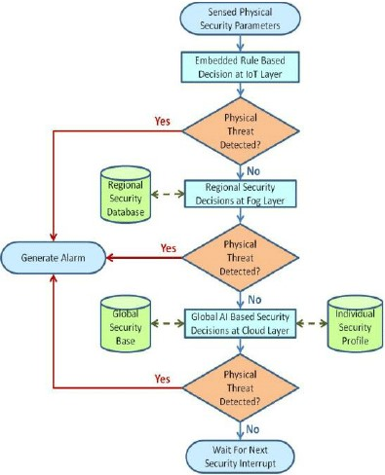
FIG.1

Step 1: System Initialization Gather the necessary hardware components, including a GPS module, a microcontroller (e.g., Arduino), a GSM module for communication, and any sensors you want to integrate (e.g., for environmental monitoring).
Step 2: GPS Data Acquisition Set up the GPS module to acquire location data. Periodically read GPS data (latitude and longitude).
Step 3: Data Processing and Analysis Analyze the GPS data to identify the user's location. Apply filtering or smoothing techniques to improve location accuracy.
Step 4: Geofencing Define geographical boundaries (geofences) for the user's safety. Compare the user's location with the geofence boundaries.
Step 5: User Safety Check If the user is within the defined geofence boundaries, continue monitoring. Step 6: User Outside Geofence If the user exits the geofence, the system triggers an alert.
Step 7: Alert Generation and Communication If an alert is triggered (user outside geofence), the system generates an alert. Use the GSM module to send alerts via SMS, calls, or data transmission.
Step 8: Emergency Contacts Define a list of emergency contacts. Send alerts and location information to these contacts.
Step 9: Continuous Monitoring Continuously monitor the user's location and safety status.
Step 10: Environmental Sensors (Optional) Integrate environmental sensors to monitor factors such as temperature, humidity, or air quality for additional safety features.
Step 11: Battery Management Implement power-saving features to maximize device uptime, as continuous GPS usage can drain the battery quickly.
Step 12: User Interface (Optional) Develop a user interface or mobile application for the user to configure settings and receive alerts.
Step 13: Testing and Calibration Test the system under various scenarios to ensure accuracy and reliability. Calibrate the system for optimal performance.
Step 14: Deployment Deploy the human security system for real-world use. Here's a simple flowchart representing the operation of the system:

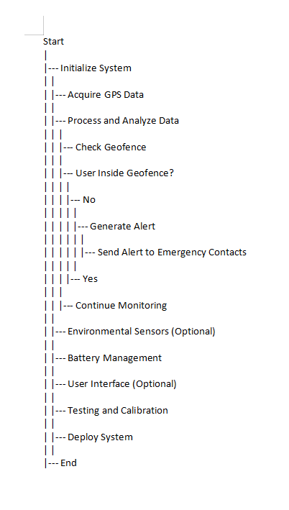
Fig.2
Chapter 4 Results analysis and validation

CODE:

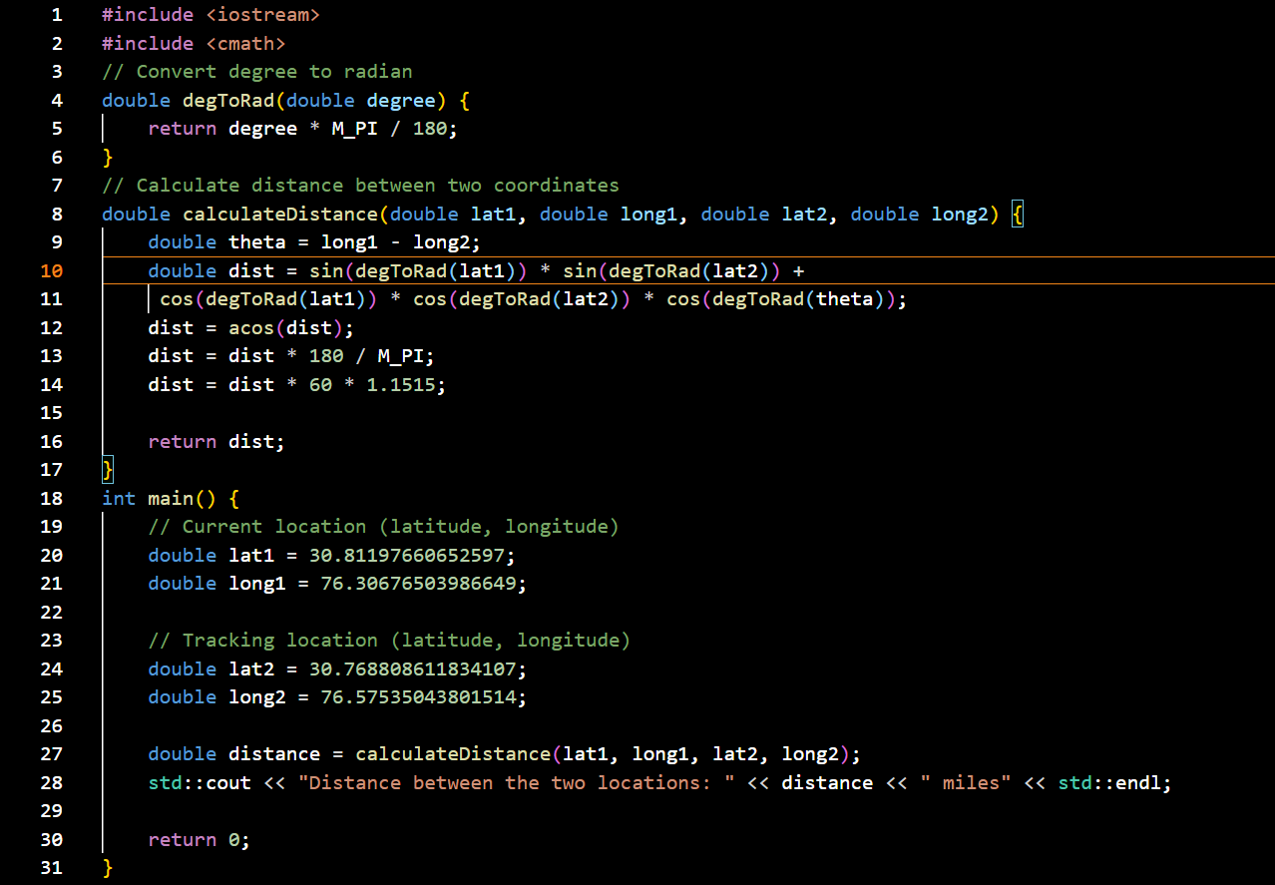

OUTPUT:
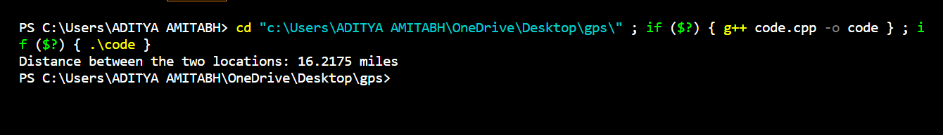

- Requirements Analysis: Use modern project management tools like JIRA or Trello to document and track project requirements. Create a requirements document detailing the desired features and functionalities of the GPS-based human security system.
- System Design: Use computer-aided design (CAD) software (e.g., AutoCAD or SolidWorks) for creating detailed drawings and schematics of the system components. Develop 3D solid models to visualize the physical layout and components.
- Component Selection and Procurement: Utilize supply chain management software to source components and materials efficiently.
- Hardware Integration: Employ electronic design automation (EDA) tools like Altium Designer or KiCad for designing custom PCBs if necessary. Develop circuit diagrams and schematics using EDA tools for GPS modules, microcontrollers, sensors, and communication devices.
- Firmware and Software Development: Use integrated development environments (IDEs) like Arduino IDE or Visual Studio for programming microcontrollers and implementing the system's logic. Develop a user interface or mobile application for configuration and alert management using software development tools.
- Data Visualization: Implement data visualization tools (e.g., Tableau, Power BI) to display real-time location data and environmental sensor readings.
- Testing and Characterization: Set up a controlled testing environment to validate the system's performance. Utilize GPS simulator tools to test the system's behavior under different GPS conditions. Employ data analysis and interpretation tools (e.g., Python with data science libraries) to process and interpret collected data.
- Data Validation: Compare the system's GPS data with ground truth data to validate accuracy.
- Communication: Use project management and communication tools (e.g., Slack, Microsoft Teams) to facilitate team collaboration and project updates. Communicate with stakeholders, including end-users and emergency contacts, through the system's communication features.

Chapter 5: Conclusion and future work

In conclusion, the implementation of a human security system using GPS tracking technology offers a powerful solution for enhancing personal safety and security. This system combines the benefits of location-based data with modern engineering tools and methodologies to create a robust and effective security framework. Key takeaways from the concept of human security using GPS tracking include:

- Improved Safety: GPS tracking provides real-time location data, enabling individuals to monitor and enhance their safety, especially in potentially dangerous situations.

- Efficient Design and Development: Modern engineering tools, such as CAD, EDA, and software development environments, play a vital role in designing and developing the system. They streamline the process and ensure precision.

- Data-Driven Insights: Data collected from GPS tracking and integrated environmental sensors offer valuable insights into the user's surroundings, enabling informed decision-making.

- Communication and Alerting: The system's communication capabilities, including SMS, calls, and data transmission, allow for immediate alerts to be sent to emergency contacts when the user's safety is compromised.

- Testing and Validation: Rigorous testing, including GPS simulation and data analysis, is essential to validate the system's accuracy and reliability.

- User-Friendly Interfaces: User interfaces and mobile applications simplify system configuration and interaction, making it accessible to a broader user base.

- Project Management and Reporting: Project management tools aid in tracking progress, while detailed reports provide documentation of the system's design, development, and testing.

- Deployment and Maintenance: Deploying the system in the target environment and implementing remote monitoring and updates ensure ongoing functionality and adaptation to changing needs.

9. Training and Education: Effective end-user training ensures that users can confidently use and manage the system to maximize their personal security.

REFERENCES

[1].https://playacademy.exceedlms.com/student/path/313809?referrer=interstitial&_gl=1*rn7vry*_gcl_aw*R0NMLjE2OTgxMzQ3OTguQ2p3S0NBancxdDJwQmhBRkVpd0FfLUEtTlBPTGF2cVZQaDRITFpRWnU1Z2pkdC11QmMtRnFoaGVoSmx6VG02WTJPU3ctZXZtT0RsclBSb0NoVmdRQXZEX0J3RQ..*_gcl_dc*R0NMLjE2OTgxMzQ3OTguQ2p3S0NBancxdDJwQmhBRkVpd0FfLUEtTlBPTGF2cVZQaDRITFpRWnU1Z2pkdC11QmMtRnFoaGVoSmx6VG02WTJPU3ctZXZtT0RsclBSb0NoVmdRQXZEX0J3RQ..*_gcl_au*MTkyNzg0MDE0MS4xNjk4MTM0Nzk4*_ga*MTc4OTQwNTA0Mi4xNjg4ODM4Njg0*_ga_76THV10NTW*MTY5ODE3NjMzNC44LjAuMTY5ODE3NjMzNC4wLjAuMA..&_ga=2.157416376.369937170.1698134798-1789405042.1688838684&_gac=1.180481493.1698134802.CjwKCAjw1t2pBhAFEiwA_-A-NPOLavqVPh4HLZQZu5gjdt-uBc-FqhhehJlzTm6Y2OSw-evmODlrPRoChVgQAvD_BwE

- Amazon Web Services. Authenticating Users of AWS Mobile Applications with a Token Vending Machine. AWS Identity and Access Management, July 2013. http://aws.amazon.com/articles/4611615499399490.

- R. Chirgwin. Amazon Is Decompiling Our Apps in Security Gaff Hunt, Says Dev. The Register, Mar. 2014. http://www.theregister.co.uk/2014/03/31/dev_lashes_ out_at_amazon_for_decompiling_his_app

[4].MixRank. http://www.mixrank.com
Y. Zhang, G. Huang, X. Liu, W. Zhang, H. Mei, and S. Yang. Refactoring Android Java Code for On-Demand Computation Offloading. In Proceedings of the 27th Annual ACM SIGPLAN Conference on Object-Oriented Programming, Systems, Languages, and Applications (OOPSLA 2012), Oct. 2012

